The Water Cycle
Adapted from the Live From Earth and Mars Website and Montana.edu
Time requirement: 90 minutes (Activity only. Prep and clean-up time will take 60 minutes and 15 minutes, respectively.)

Summary of Activity: Students become water droplets to learn about the journey of water through the water cycle.

Concepts to Teach: Cycles

Standards Addressed: 6.2E.1, 7.2L.2, 8.2E.3

Goal(s):
- Learn about the stages of the water cycle.
- Learn about the connection between water all over the planet.

Specific Objectives:
- Explain what happens at each stage of the water cycle.
- Create landscapes for water to travel to.
- Become a water droplet and travel through the landscapes as all the different forms of water.

Vocabulary: (See glossary in Additional Resources section)
condensation, cycle, evaporation, groundwater, precipitation, transpiration, watershed

Required Materials:
- Pencils/Markers/Crayons  - Butcher paper or poster board  - 9 dice or constructed cubes  - Tally worksheet (included)  - Droplet cut-out (included) | - Yarn or string  - Hole punch  - Internet access the whole class can see

Prerequisites: None
……………………………………………………………………..

Background
The water cycle has no starting point. But, we'll begin in the oceans, since that is where most of Earth's water exists. The sun, which drives the water cycle, heats water in the oceans. Some of it evaporates as vapor into the air. Ice and snow can sublimate directly into water vapor. Rising air currents take the vapor up into the atmosphere, along with water from evapotranspiration, which is water transpired from plants and evaporated from the soil. The vapor rises into the air where cooler temperatures cause it to condense into clouds.

Air currents move clouds around the globe, cloud particles collide, grow, and fall out of the sky as precipitation. Some precipitation falls as snow and can accumulate as ice caps and glaciers, which can store frozen water for thousands of years. Snowpacks in warmer climates often thaw and melt when spring arrives, and the melted water flows overland as snowmelt. Most precipitation falls back into the oceans or onto land, where, due to gravity, the precipitation flows over the ground as surface runoff. A portion of runoff enters rivers in valleys in the landscape, with streamflow moving water towards the oceans. Runoff, and ground-water seepage, accumulate and are stored as freshwater in lakes. Not all runoff flows into rivers, though. Much of it soaks into the ground as infiltration. Some water infiltrates deep into the ground and replenishes aquifers (saturated subsurface rock), which store huge amounts of freshwater for long periods of time. Some infiltration stays close to the land surface and can seep back into surface-water bodies (and the ocean) as groundwater discharge, and some ground water finds openings in the land surface and emerges as freshwater springs. Over time, though, all of this water keeps moving, some to reenter the ocean, where the water cycle "ends" ... oops - I mean, where it "begins."
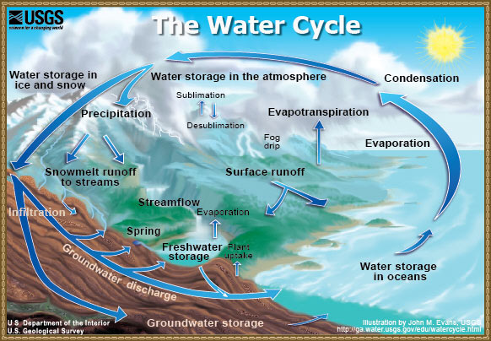

Preparation
- Teachers should read through the background information and familiarize themselves with the vocabulary.
- Cubes for the stations needs to be constructed, if that is what teachers want to use. Use the tables to decide what goes on each of the sides of the cubes or just use regular dice. See the tables below for more instruction.
- The website with the water cycle song should be visited prior to the lesson and the teacher should decide if the song is appropriate for their class.
………………………………………………………………
Lesson Procedure/Activity Description
Introduction:
Begin with a discussion about cycles. What do students think of when they hear that word? Try to steer the students to the understanding that a cycle is merely something that happens continually in a circle, so there is no beginning or end.

Water is cycled through earth systems in a continual fashion. Use the following questions as a guide for a class discussion.
- Does the earth have more or less water than it did 1,000 years ago? Explain.
- Is there water on the ground? How did it get there?
- How does water get into the oceans?
- What are clouds made of?
- How does rain form?

Listen to the water cycle song by Mr. Davies: http://www.youtube.com/watch?v=okZBiy_IdBA&feature=related
Use the depiction of the water cycle below (in the background section) to make sure students are clear on what each stage of the water cycle entails. Take the time to answer any questions about what the words mean or the order in which the stages occur (the answer to that is that there is no order!).
Main Activity:
- Explain to the students that they will become water droplets. Pass out the water droplet outline and have them draw their faces or some things that represent them as a person on the water droplet. Cut out the droplet, use a hole punch to cut through the hole and have the students fashion a piece of yarn or string so they can wear their droplets.
- Have students list out the places that water can go or things that might use water when it falls to the earth. Write this list on the board.
- After the list is formed, try to fit them within the following 9 categories:

Soil | Plants | Rivers
Lakes | Clouds | Ocean
Animals | Groundwater | Glaciers

- You could also list out the categories on the board as it relates to what the students are saying. For instance, if one student says “trees”, write plants and direct all other plant suggestions to this category.
- Divide students into 9 groups and assign each group one of the categories.
- Each group uses a piece of butcher paper or poster board to illustrate their assigned category. Give them about 15 minutes to draw their categories. The finished products should be hung up around the classroom.
- Pass out the Water Droplet Journey Worksheet. Explain that each time they visit a site, they should make a tally mark on the sheet. Students should begin in their assigned group and should now assume that they are drops of water. Have the students predict where they think they will spend the most amount of time as droplets.
- Students line up and take turns rolling the die. The die will indicate where to go next- either by picture or corresponding number.
- Each visit to the various locations should be recorded on the tally sheet. Remember that if the student is instructed to STAY, they should tally that station again and get back in line to roll the die again.
- Allow students to remain water droplets for 15-20 minutes. Walk amongst the locations to answer any questions or help distracted students move through the activity. After the “flow” stops, students should count up their tallies at each station.

Conclusion:
- Students should return to their original groups. Have the students predict where they think water droplets visited most. Each student who expresses an opinion about which site was visited most often should present an argument for why they think water spends the most amount of time there.
- One representative from each group should survey the entire class to get totals on how many times individuals visited each site. For example, a student from the Clouds should visit each group and get totals from each student and keep track of these numbers. Have them use the back of their tally sheet. They should add the numbers to get a final total.
- Write these totals on the board.
- Within their original groups, students should work together to create a graph based on the location and the frequency of visits. This should explain where water spends the most time. Or, students can calculate averages.
- Discuss the results as a class.
- Review the stages of the water cycle and what each station represents. For example, Clouds are where condensation happens but evaporation can happen from rivers, lakes, or the ocean. So on and so on.

Assessment
- Graphs can be assessed for completeness and accuracy.
- Create a “quiz” with questions about the graphs that students can take based on the graphs created by their classmates.
Adaptations & Extensions
- Students can research each stage of the water cycle more thoroughly and created their own depiction of the cycle based on the information each has gathered. This larger, more complete version of the cycle can be hung on the wall or in the hallway where other classes can benefit as well.
- To shorten this activity, the song, the droplet, or the poster creation can be omitted.
- To use this for younger students, have them create the droplets and the poster. Then, as a class, with the teacher as the “die-roller,” go through the activity and keep one tally sheet for everyone. Or, for very young students, the entire class can just be guided through each station with the teacher explaining each step along the way.
- To use this for older students, omit the song and require them to come up with the information about each stage of the cycle through their own research. After they are familiar with the concepts and the game, have them run the activity for a younger class.

Additional Resources
Glossary
- Condensation- the process of water in gas form turning into a liquid
- Cycle- a continual process that has no beginning, middle, or end
- Evaporation- the process of water turning from liquid to gas
- Groundwater- liquid water flowing under the ground or settling on earth’s surface (as in wetlands)
- Precipitation- when water turns from gas to liquid and falls to the earth (rain, snow, or sleet)
- Transpiration- the loss of water from plants
- Watershed- the area of land where all of the water that is under it or drains off of it goes into the same place

Standards Addressed:
6.2E.1- Explain the water cycle and the relationship to landforms and weather.
6.3S.2- Organize and display relevant data, construct an evidence-based explanation of the results of an investigation, and communicate the conclusions.
7.2L.2- Explain the process by which plants and animals obtain energy and materials for growth and metabolism
7.3S.2- Organize, display, and analyze relevant data, construct an evidence-based explanation of the results of an investigation, and communicate the conclusions including possible sources of error.
8.2E.3- Explain the causes of patterns of atmospheric and oceanic movement and the effects on weather and climate.
8.3S.2- Organize, display, and analyze relevant data, construct an evidence-based explanation of the results of an investigation, and communicate the conclusions including possible sources of error. Suggest new investigations based on analysis of results.

Water Droplet Journey Sheet

Station | # of times visited  Any time you have to STAY, make another tally for that station. | Total
Soil

Plants

Rivers

Lakes

Clouds

Oceans

Animals

Groundwater

Glaciers

Constructing the Cubes
For making the cubes, these tables will indicate what you should put on each die. For example, the Soil Station should have a die that have one side each of: Rivers, Plants, Groundwater, and STAY. Two sides should have Clouds. Another example is that for the Plants Station, four sides should say Clouds and the other two should say STAY. Possible options for graphics are on the next page. Make sure to count out how many of each you will need when printing. If making the cubes is too time-consuming, use regular die and just assign number values to each station. Student can roll the die and use the number rolled as the indicator for where to go next. You can print this page and cut for printouts that can be posted at each station.

Soil Station | Plants Station | Rivers Station
  If you roll …. | …go to:
  1 | Clouds
  2 | Rivers
  3 | Plants
  4 | Groundwater
  5 | Clouds
  6 | STAY
  If you roll …. | …go to:
  1 | STAY
  2 | Clouds
  3 | Clouds
  4 | Clouds
  5 | Clouds
  6 | STAY
  If you roll …. | …go to:
  1 | Animals
  2 | Lakes
  3 | Groundwater
  4 | Oceans
  5 | Clouds
  6 | STAY
Lakes Station | Clouds Station | Ocean Station
  If you roll …. | …go to:
  1 | Clouds
  2 | Ocean
  3 | STAY
  4 | STAY
  5 | Lakes
  6 | Groundwater
  If you roll …. | …go to:
  1 | Soil
  2 | Lakes
  3 | Ocean
  4 | Glaciers
  5 | STAY
  6 | Ocean
  If you roll …. | …go to:
  1 | Clouds
  2 | Stay
  3 | Stay
  4 | Stay
  5 | Stay
  6 | Clouds
Animals Station | Groundwater Station | Glaciers Station
  If you roll …. | …go to:
  1 | Soil
  2 | Clouds
  3 | STAY
  4 | Clouds
  5 | Clouds
  6 | Soil
  If you roll …. | …go to:
  1 | STAY
  2 | Lakes
  3 | Lakes
  4 | STAY
  5 | Rivers
  6 | STAY
  If you roll …. | …go to:
  1 | Groundwater
  2 | STAY
  3 | Clouds
  4 | STAY
  5 | Rivers
  6 | STAY

Graphics for Cubes (optional)

Soil Station  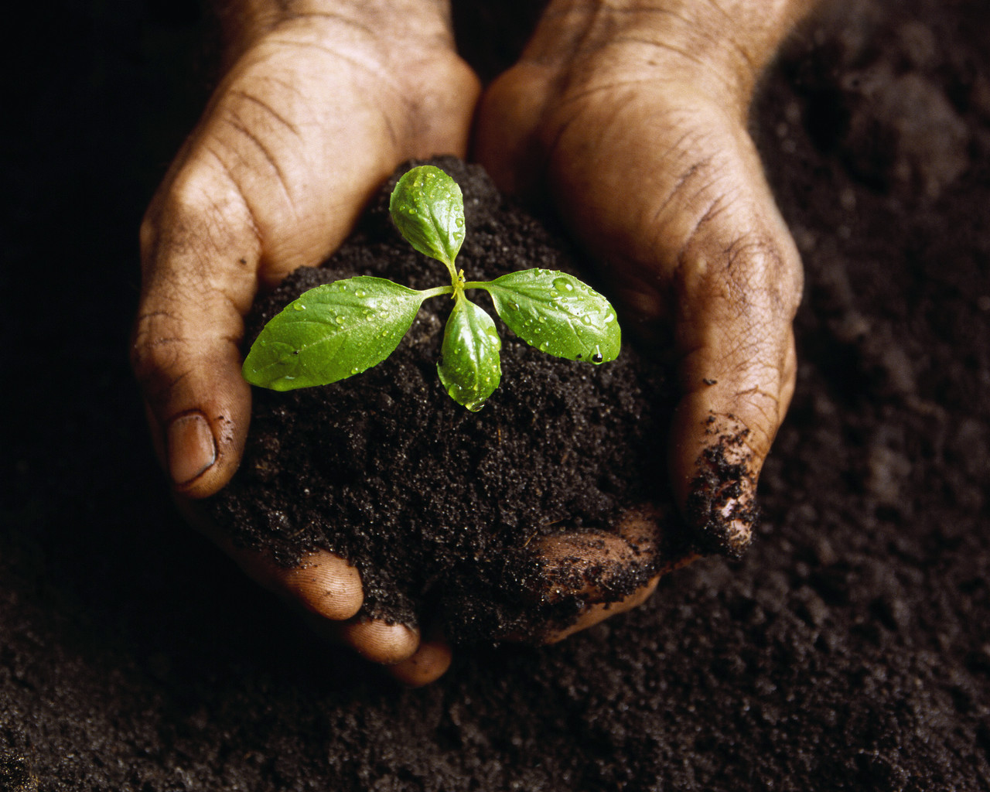 | Plants Station  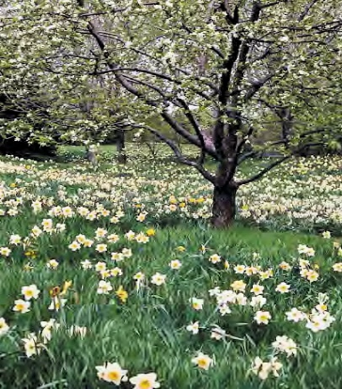 | Rivers Station  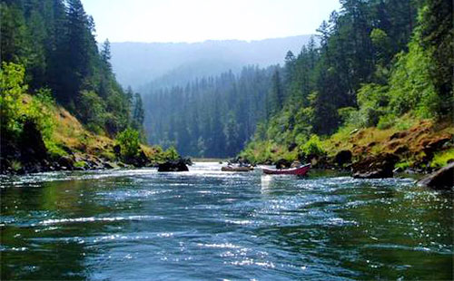
Lakes Station  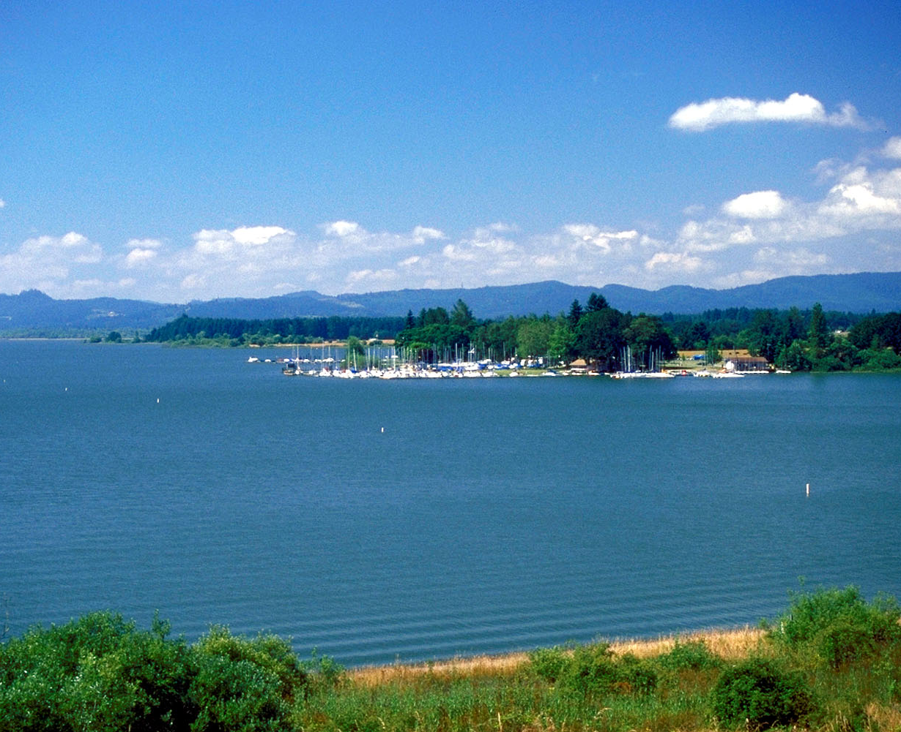 | Clouds Station  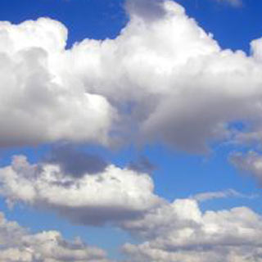 | Ocean Station  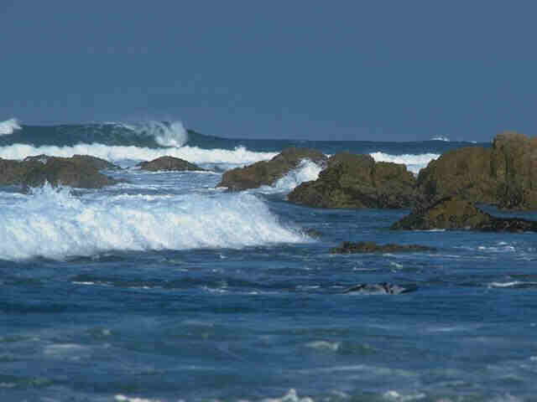
Animals Station  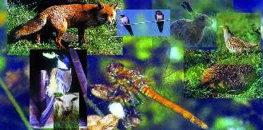 | Groundwater Station  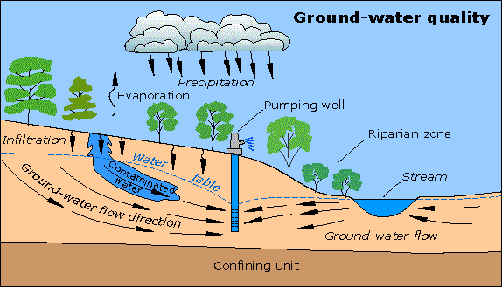 | Glaciers Station  

